1. **What is Error, Defect, Bug and failure?**

* A Human can make an Error.
* An **Error** is ‘A Human Action that produces an Incorrect Result’.
* The error can cause a defect.
* A **Defect** is ‘A flaw in a component or system that can cause the component or system to fail to perform its required function ’.
* A **Defects** can be in the Software, System or in a document.
* Defects occur because human beings are fallible
* Also because of:
* Time pressure
* Complex code
* Complex Infrastructure
* Changed technologies
* And /or many system interactions
* A **Defect** may result in a Failure.
* A **Failure** is a ‘**Deviation of the component or system from its expected delivery, service or result’.**
* **Failures**  can be caused by environmental conditions as well
* E.g. radiation ,magnetism, electronic fields
* Pollution can cause faults in firmware or influence the execution of software by changing hardware conditions

**Errors, Defects and Failures**

**Error**

A Human action that produces an incorrect

result

Can manifest as

A Flaw in a component or system that can cause the component or system to fail perform its required function

**Defects**

**Failure**

May result in

Deviation of the component or system from its expected delivery, service or result

* **Errors, Defects and Failures:**
* **“A mistakes in coding is called error , error found by tester is called defect, defect accepted by development team then it is called bug build does not meet the requirements then it is failure ”**
* **Error:** A discrepancy between a computed, observed, or measured value and condition and the true, specified, or theoretically correct value or condition. This can be misunderstanding of the internal state of the software, an oversight in terms of memory management, conclusion about the proper way to calculate a value, etc.
* **Failure:** The inability of a system or component to perform its required functions within specified performance required. See: bug, crash, exception, and fault.
* **Bug:** A fault in program which causes the program to perform it’s an unintended or unanticipated manner. See: anomaly, defect, error, exception, and fault. Bug is Terminology of Tester.
* **Fault:** An incorrect step, process, or data definition in a computer program which causes the program to perform in an unintended or unanticipated manner. See: bug, defect, error, exception.
* **Defect:** Commonly refers to several troubles with the software products, with its external behavior or with its features.

1. **What is a 7key principle? Explain in detail?**

General Testing principles:

1. Testing shows the presence of defects
2. Exhaustive Testing is Impossible!
3. Early testing
4. Defect Clustering
5. The pesticide Paradox
6. Testing is context Dependent
7. Absence of Error fallacy
8. **Testing shows the presence of defects:**

* The goal of software testing is to make the software fail.
* Software testing reduces the presence of defects
* Software testing talks about the presence of defects and doesn’t talk about the absence of defects.
* Software testing can ensure that defects are present but it cannot prove that software is defect-free.
* Even multiple tests can never ensure that software is 100% bug-free.
* Testing can reduce the number of defects but not remove all defects

1. **Exhaustive Testing is impossible!**

* It is the process of testing the functionality of the software in all possible inputs (valid or invalid) and pre-conditions is known as exhaustive testing.
* Exhaustive testing is impossible means the software can never test at every test case.
* It can test only some test cases and assume that the software is correct and it will produce the correct output in every test case.
* If the software will test every test case then it will take more cost, effort, etc., which is impractical.

1. **Early Testing:**

* To find the defect in the software, early test activity shall be started.
* The defect detected in the early phases of SDLC will be very less expensive.
* For better performance of software, software testing will start at the initial phase i.e. testing will perform at the [requirement analysis](https://www.geeksforgeeks.org/requirements-gathering-introduction-processes-benefits-and-tools) phase.

.

1. **Defect Clustering:**

* In a project, a small number of modules can contain most of the defects.
* The Pareto Principle for software testing states that 80% of software defects come from 20% of modules.
* They are clustered.
* In other words, most defects found during testing are usually confined to a small number of modules.

1. **Pesticide paradox:**

* Repeating the same test cases, again and again, will not find new bugs.
* So it is necessary to review the test cases and add or update test cases to find new bugs.

**6. Testing is context-dependent:**

* The testing approach depends on the context of the software developed.
* Different types of software need to perform different types of testing.
* For example, the testing of the e-commerce site is different from the testing of the Android application.

**7. Absence of Error fallacy:**

* If a built software is 99% bug-free but does not follow the user requirement then it is unusable
* It is not only necessary that software is 99% bug-free but it is also mandatory to fulfill all the customer requirements.

**Testing shows o presence of defects**

**Exhaustive Testing is Impossible!**

**Principles of software Testing**

**Absence of error fallacy**

**Testing is context-Dependent**

**Pesticide Paradox**

**Defect Clustering**

**3. Difference between QA vs. QC vs. Tester?**

|  |  |  |  |
| --- | --- | --- | --- |
| **S.N** | **Quality Assurance** | **Quality Control** | **Testing** |
| 1 | Activities which ensures the implementation of processes,  Procedures and standards in context to verification of developed software and intended requirements. | Activities which ensures the verification of developed software with respect to documented (or not in some cases) requirements. | Activities which ensures the identification of bugs /error/defects in the software. |
| 2 | Focuses on processes and procedures rather than conducting actual testing on the system. | Focuses on actual testing by executing Software with intend to identify bug /defect through implementation of procedures and process. | Focuses on actual testing. |
| 3 | Process oriented activities. | Product oriented activities. | Product oriented activities. |
| 4 | Preventive activities. | It is a corrective process. | It is a preventive process. |
| 5 | It is a subset of Software Test Life Cycle(STLC) | QC can be considered as the subset of quality Assurance. | Testing is the subset of Quality control. |

**4. Difference between Verification and Validation?**

|  |  |  |
| --- | --- | --- |
| **Criteria** | **Verification** | **Validation** |
| **Definition** | The process of evaluating the work products (not the actual final product of a development) phase to determine whether they meet the specified requirements for that phase. | The process of evaluating the software during or at the end of the development process to determine whether it satisfies specified business requirements. |
| **Objectives** | To ensure that the product is being built according to the requirements and design specifications. In other words, to ensure that work products meet their specified requirements. | The ensure that the product actually meet the user’s needs, and that the specifications were correct in the first place. In other words, to demonstrate that the product fulfils its intended use when placed in its intended environment. |
| **Questions** | Are we building the product right? | Are we building the product right? |
| **Evaluation**  **Items** | Plans ,Requirements, specs, Design Specs, Code, Test cases | The actual product /software. |
| **Activities** | * Reviews * Walkthroughs * Inspections | * Testing |

**5. Explain the difference between Functional Testing and non-functional Testing?**

|  |  |
| --- | --- |
| **Functional Testing** | **Non –Functional Testing** |
| Functional testing is performed using the functional specification provided by the client and verifies the system against them. Functional requirements. | Non –functional testing checks the performance, reliability, scalability and other non-functional aspects of the software system. |
| Functional testing is executed first. | Non –functional testing should be performed after functional testing. |
| Manual Testing and Automation tools can be used for functional testing | Using tools will be effective for this testing. |
| Business requirements are the inputs to functional testing. | Performance parameters :speed, scalability inputs for this testing |
| Functional testing describes what the product does | Nonfunctional testing describes how good the product works. |
| Easy to do manual testing | Tough to do manual testing. |
| Types of Functional Testing are   * Unit Testing * Smoke Testing * Sanity Testing * Integration Testing * Whit box Testing * Black box Testing * User Acceptance Testing * Regression Testing | Types of Nonfunctional Testing are : 1.Performance Testing  2.Load Testing  3.Volume Testing  4.Stress Testing  5.Security Testing  6. Installation Testing  7.Penetration Testing  8.Compatibility Testing  9.Migration Testing |

1. **What is white box testing and list the types of white box testing?**

* White box testing is a [software testing technique](https://www.geeksforgeeks.org/software-testing-techniques/)that involves testing the internal structure and workings of a [software application](https://www.geeksforgeeks.org/what-is-application-software/).
* The tester has access to the source code and uses this knowledge to design test cases that can verify the correctness of the software at the code level
* White box testing is also known as [structural testing](https://www.geeksforgeeks.org/structural-software-testing/)or [code-based testing,](https://www.geeksforgeeks.org/what-is-code-driven-testing-in-software-testing/)and it is used to test the software’s internal logic, flow, and structure.
* The tester creates test cases to examine the code paths and logic flows to ensure they meet the specified requirements.
* Before we move in depth of the white box testing do you know that there are many different type of testing used in industry.
* Some automation testing tools are there which automate the most of testing so if you wish to learn the latest industry level tools then you check-out our [manual to automation testing course](https://gfgcdn.com/tu/QW3/)in which you will learn all these concept and tools

## Types of White Box Testing:

White box testing can be done for different purposes. The three main types are : 1.Unit testing

2. Integration Testing

3. Regression Testing

1. **Unit Testing:**

* Checks if each part or function of the application works correctly.
* Ensures the application meets design requirements during development.

1. **Integration Testing:**

* Examines how different parts of the application work together.
* Done after unit testing to make sure components work well both alone and together.

1. **Regression Testing:**

* Verifies that changes or updates don’t break existing functionality.
* Ensures the application still passes all existing tests after updates.
* Objective of White Box Testing:
* White Box Testing serves a crucial role in software testing by allowing testers to inspect and verify the inner workings of a software system, including its code, infrastructure, and integrations.
* **The key objective of White Box Testing includes**:

**1. Thoroughness**: It provides complete coverage, ensuring every part of the software’s internal structure is tested.

2. **Automation**: Test cases can be easily automated, saving time and resources.

**3. Optimization**: It helps in code optimization by identifying hidden errors and redundancies

**4. Introspection**: It provides an in-depth understanding of the software, which can be invaluable for future development and maintenance.

**White box testing techniques:**

One of the main benefits of white box testing is that it allows for testing every part of an application. To achieve complete code coverage, white box testing uses the following techniques:

**Statement Coverage**

**Branch Coverage**

**Path Coverage**

**Decision /Condition Coverage Coverage**

**Condition Coverage**

* 1. **Statement coverage:**
* In this technique, the aim is to traverse all statements at least once. Hence, each line of code is tested.
* In the case of a flowchart, every node must be traversed at least once.
* Since all lines of code are covered, it helps in pointing out faulty code.
  1. **Branch Coverage:**
* In this technique, test cases are designed so that each branch from all decision points is traversed at least once.
* In a flowchart, all edges must be traversed at least once.
  1. **Path Coverage:**
* This is like reading a book’s possible combination of chapters.
* In code, it means testing every possible path through the code from start to finish.
  1. **Condition Coverage:**
* This is like checking every possible answer to a question in a book.
* In code, it means testing every possible outcome of logical conditions in the code.
  1. **Decision &Condition Coverage:**
* This is like checking every possible combination of answers to multiple questions in a book.
* In code, it means testing every possible combination of outcomes in logical decisions (like a condition with and logic) in the code.

**8. What is Black Box Testing? What are the different black box testing techniques?**

* Black box testing is software testing techniques where the internal workings or code structure of the system being tested are not known to the tester.
* In other words, the tester focuses solely on the external behavior of the software, without having access to its internal source code. The name “black box” comes from the idea that the internal workings are hidden or “boxed” from the tester’s view.

**Key characteristics of black box testing include:**

* **Independent Testing**: Black box testing is typically performed by testers who are independent of the development team. This ensures a fresh perspective and helps identify issues that developers might overlook.
* **Requirements-Based Testing**: Testers design test cases based on the software’s requirements and specifications, without being concerned about how the code is implemented.
* [**Functional Testing**](https://www.browserstack.com/guide/functional-testing): The main goal of black box testing is to assess the functionality of the software, checking if it meets the expected behavior and delivers the desired outputs for various inputs.
* **No Knowledge of Internal Code**: Testers do not have access to the source code, architecture, or design details of the software. They interact with the system through its user interfaces or APIs.
* **Different Types of Black Box Testing**

Black box testing encompasses several types of testing techniques, each with a specific focus and objective. Some of the main types of black box testing include:

* [**Functional Testing**](https://www.browserstack.com/guide/functional-testing)**:**This type of black box testing verifies that the software’s functions and features work as expected and adhere to the specified requirements. Testers use functional test cases to validate the application’s inputs, outputs, and interactions, without being concerned about the internal code.
* [**Non-Functional Testing**](https://www.browserstack.com/guide/what-is-non-functional-testing): Unlike functional testing, non-functional testing evaluates aspects of the software that are not related to its specific functions. It includes tests for performance, usability, security, scalability, reliability, and other quality attributes.
* [**Regression Testing**](https://www.browserstack.com/guide/regression-testing)**:** Regression testing is performed to ensure that recent changes or updates to the software do not adversely affect existing functionality. Testers use a set of predefined test cases to verify that new features or bug fixes have not introduced new issues.
* **User Interface (UI) Testing:** [UI testing](https://www.browserstack.com/guide/ui-testing-guide) focuses on validating the user interface elements of the software, such as buttons, menus, forms, and layout. The goal is to ensure that the UI is [user-friendly](https://www.browserstack.com/guide/make-website-user-friendly), consistent, and functions correctly.
* [**Usability Testing**](https://www.browserstack.com/guide/what-is-usability-testing)**:** Usability testing assesses the software’s user-friendliness and how easily users can interact with it. Testers evaluate factors like navigation, visual appeal, ease of learning, and overall user experience.
* **Boundary Value Analysis (BVA):** BVA is a technique used to identify defects around the boundaries of input values. Test cases are designed with values at the edges of input ranges to assess how the software handles minimum and maximum limits.
* **Equivalence Partitioning:**In this technique, the input domain is divided into groups of data that are expected to behave similarly. Test cases are then derived from these partitions to minimize redundant testing.
* [**Ad-hoc Testing**](https://www.browserstack.com/guide/adhoc-testing): Ad-hoc testing is an informal and unstructured testing approach where testers explore the software freely, executing test scenarios based on their intuition and experience. It helps identify defects that might be missed by formal test cases.
* [**Compatibility Testing**](https://www.browserstack.com/guide/compatibility-testing): Compatibility testing assesses how well the software performs across different environments, such as various browsers, operating systems, devices, and network configurations.
* **Security Testing:**Security testing aims to identify vulnerabilities and weaknesses in the software’s security measures. Testers simulate attacks and check for potential security breaches.
* **Localization and Internationalization Testing:**These types of testing ensure that the software is adapted to different languages, cultures, and regional settings, and it functions correctly in various international environments.
* **Different Black Box Testing Techniques:**

Black box testing techniques focus on evaluating software from the user’s perspective, without delving into the internal code structure or logic.

**1. Equivalence Partitioning:** Divides the input data into equivalent partitions, with each partition being regarded the same by the program. Testing one representative from each partition is usually enough to cover all potential scenarios.

**Example:** For a form that accepts age input between 18 and 65, equivalence partitions might include:

* Valid partition: 18-65 (e.g., age 25)
* Invalid partition: Below 18 (e.g., age 15)
* Invalid partition: Above 65 (e.g., age 70)

**2. Boundary Value Analysis:** Tests the bounds of input ranges, as errors frequently arise on the edge of input limits.

**Example:** For an input field that accepts values from 1 to 100, boundary values would include:

* Lower boundary: 1
* Just below lower boundary: 0
* Just above upper boundary: 101
* Upper boundary: 100

**3. Decision Table Testing:** A decision table is used to represent and test different combinations of inputs and predicted outcomes. This method is effective for testing systems that involve several conditions and actions.

**Example:** For a loan application system with conditions like credit score (high/low) and income (above/below threshold), a decision table might include:

|  |  |  |
| --- | --- | --- |
| Credit Score | Income | (Loan Approved Y/N) |
| High | Above Threshold | Y |
| High | Below Threshold | Y |
| Low | Above Threshold | N |
| Low | Below Threshold | N |

**4. State Transition Testing:** Tests the system’s behavior in various states and transitions between them. It ensures that the system functions properly when transitioning from one state to another.

**Example:** For a user login system, states might include:

* Logged Out
* Logged In
* Suspended

**Transitions would be:**

* From Logged Out to Logged In (successful login)
* From Logged In to Suspended (suspend account)
* From Suspended to Logged Out (logout from suspended state)

**5. Use Case Testing:** Focuses on validating the functionality of the system based on user interactions described in use cases. It ensures that the system meets the requirements of each use case.

Example: For an online shopping application, a use case might be:

* **Use Case:** Purchase Item
* **Steps:** Select item, add to cart, proceed to checkout, enter payment details, confirm purchase
* **Expected Outcome:** Order confirmation is displayed, and order is recorded

**6. Error Guessing:** Relies on the tester’s experience and intuition to guess where errors might occur based on common mistakes, past experiences, and known problem areas.

**Example:** For a file upload feature, error guessing might include testing with:

* Files of various types (e.g., .exe, .jpg, .pdf)
* Files with very large sizes
* Files with invalid extensions

**7. All-pair Testing Technique:** All-pair testing, also known as pair wise testing, is a combinatorial testing technique that aims to cover all possible pairs of input parameters in a test set.

The purpose is to ensure that every combination of two input parameters is evaluated at least once, which aids in the detection of problems caused by interactions between parameter pairs.

**Consider a web application with three input parameters:**

* **Parameter 1:** Browser Type (Chrome, Firefox)
* **Parameter 2:** Operating System (Windows, macros)
* **Parameter 3:** User Role (Admin, Guest)

With each parameter having two possible values, there are 2 x 2 x 2 = 8 possible combinations if tested exhaustively. However, using all-pair testing, you might only need a subset of combinations to cover all pairs of values.

**Possible Test Cases:**

**Browser:** Chrome, OS: Windows, Role: Admin

**Browser:** Chrome, OS: macros, Role: Guest.

**Browser:** Firefox, OS: Windows, Role: Guest.

**Browser:** Firefox, OS: macros, Role: Admin

**These test cases ensure that each pair of input values is tested, such as:**

Browser Type and Operating System.

Browser Type and User Role.

Operating System and User Role

**8. Cause-Effect Technique:** The Cause-Effect approach, also known as Cause-Effect Graphing, is a black-box testing method that creates test cases based on the relationships between causes (inputs) and effects (outputs).

This technique aids in systematically determining the functional correctness of a system by visualizing and analyzing the logical linkages between various situations and actions.

**Some key concepts here are:**

* **Cause-Effect Graph:** A diagrammatic portrayal of the logical relationships between various input conditions (causes) and their anticipated outputs (effects). It assists in discovering and mapping how different inputs interact to produce diverse outcomes, allowing for more effective test case creation.
* **Cause:** An input condition or factor that determines system behaviour. Examples include user inputs, system settings, and configuration parameters.
* **Effect:** The result of the cause. It is the system’s response to the provided input. Examples include system outputs, status messages, and changes in system behavior.

**Example:**

Consider an online account login system with the following input conditions (causes) and expected outputs (effects):

**Causes:**

* Correct username
* Correct password
* Incorrect username
* Incorrect password
* Account locked

**Effects:**

* **Login Success:** If the username and password are both correct and the account is not locked.
* **Login Failure:** If either the username or password is incorrect, or the account is locked.

**Cause-Effect Graph:**

* Cause 1 + Cause 2 → Effect 1 (Successful Login)
* Cause 3 + Cause 4 → Effect 2 (Login Failure)
* Cause 5 → Effect 3 (Account Locked)

**Derived Test Cases:**

* Correct username + Correct password (Expected: Login Success)
* Correct username + Incorrect password (Expected: Login Failure)
* Incorrect username + correct password (Expected: Login Failure).
* Account locked + Correct username + Correct password (Expected: Account Locked)
* **Example of Black Box Testing:**

A simple black box testing example for login functionality of a web application. In this scenario, we will test the login page without having access to the internal code or implementation details.

**Test Case Name**: Verify successful login with valid credentials.

**Test Steps**:

1. Open the web browser.
2. Enter the URL of the application’s login page.
3. Enter a valid username in the username field.
4. Enter a valid password in the password field.
5. Click on the “Login” button.
6. Wait for the application to process the login request.

**Expected Result**: The user should be successfully logged into the application’s dashboard/homepage.

**Test Case Status**: PASS (if the user is redirected to the dashboard/homepage)

**Test Case Name**: Verify unsuccessful login with invalid credentials.

**Test Steps**:

1. Open the web browser.
2. Enter the URL of the application’s login page.
3. Enter an invalid username (e.g., “invalid user”) in the username field.
4. Enter an invalid password (e.g., “wrong password”) in the password field.
5. Click on the “Login” button.

Wait for the application to process the login request.

**Expected Resul**t: The login attempt should fail, and an appropriate error message (e.g., “Invalid username or password”) should be displayed on the login page.

**Test Case Status**: PASS (if the error message is displayed)

**9. What Is Functional System Testing?**

* Functional testing is a type of software testing that verifies that each function of the software application behaves according to the specific requirements and meets expectations in different conditions.
* The goal of functional testing is to validate the system’s features, capabilities, and interactions with different components.
* It involves testing the software’s input and output, data manipulation, user interactions, and the system’s response to various scenarios and conditions.
* Functional testing is only concerned with validating if a

System works as intended.

* Functional testing checks an application, website, or system to ensure that it is doing exactly what it is meant to.
* Unlike other types of testing that might focus on performance, security, or usability, functional testing is primarily concerned with the correctness of the application’s functionality.

**Example of Functional Testing:** Consider the example of testing a login feature. When you perform functional testing in this context, you verify that users can log in when the credentials are submitted, see the right error messages upon submitting incorrect credentials and reset their password easily.

**Benefits of Functional Testing:**

* Helps in ensuring the software fulfills user needs
* Helps identify functional issues early on
* Enhances application quality and user experience
* Ensures application compatibility across different platforms
* Verifies user workflows and interactions

**Types of Functional Testing:**

**Here are the types of functional testing:**

* 1. **Unit Testing:**
* This is performed by developers who write scripts that test if individual components/units of an application match the requirements.
* This usually involves writing tests that call the methods in each unit and validate them when they return values that match the requirements.
* In unit testing, [code coverage](https://www.browserstack.com/guide/code-coverage-techniques) is mandatory. Ensure that test cases exist to cover the following:
* Line Coverage
* Code path Coverage
* Method Coverage
  1. **Smoke Testing:**

This is done after the release of each build to ensure that software stability is intact and not facing any anomalies.

* 1. **Sanity Testing:**

Usually done after smoke testing, this is run to verify that every major functionality of an application is working perfectly, both by itself and in combination with other elements.

* 1. **Regression Testing:**

This test ensures that changes to the codebase (new code, debugging strategies, etc.) do not disrupt the already existing functions or trigger some instability.

* 1. **Beta/Usability Testing:**

In this stage, actual customers test the product in a production environment. This stage is necessary to gauge how comfortable a customer is with the interface. Their feedback is taken for implementing further improvements to the code.

* 1. **White Box Testing:**

In White box testing, the tester validates the internal functioning of a software system.

* 1. **Integration Testing:**
* If a system requires multiple functional modules to work effectively, integration testing is done to ensure that individual modules work as expected when operating in combination with each other.
* It validates that the end-to-end outcome of the system meets these necessary standards.

**8. Grey Box Testing:**

Grey-box testing Integrates aspects of both black-box and white-box testing, where the internal functions of the applications are partially tested. The functionality and security are tested here by utilizing the system’s architecture.

**9. Exploratory Testing:**

In exploratory testing, testers explore the software to detect issues and evaluate user experience without depending on predefined test cases.

**10. Black box Testing:**

In Black box testing, the software system’s functionality is validated without examining its internal functions. Testers assess the inputs, outputs, and user interactions to ensure the systems fulfill requirements.

**11. Component Testing:**

* Component testing is performed right after unit testing.
* In this approach, test objects are tested independently as a component without combining with other components.

**12. Database Testing:**

Database testing verifies the accuracy and reliability of data within a database by making sure that database aspects like schema, CRUD (Create, Read, Update, Delete) etc. function as expected under different conditions.

**13. Recovery Testing:**

Recovery testing validates the application’s ability to recover from various types of failures.

**14. Static Testing:**

Static testing is a type of functional testing approach that includes the assessment of the software’s code, design, or documentation without actually executing the program.

**10. What is Non-Functional Testing?**

* Non-functional testing is essential for confirming the software’s reliability and functionality.
* Non-functional testing focuses on evaluating the system’s performance, scalability, security, usability, and reliability, rather than its specific functionality.
* It ensures that the system can handle real-world demands and provides a seamless, high-quality user experience.
* **Examples of non-functional testing include:**
* Performance testing
* Scalability testing
* Usability testing
* Security testing
* Localization testing
* Reliability testing
* **Core Objectives of Non-Functional Testing:**
* Below are some core objectives of non-functional testing and their explanation in detail.
* Enhancing Usability and Effectiveness
* Minimizing Production Risks and Costs
* Improving Product Setup and Operations
* Measuring and Analyzing Metrics
* Understanding Technology and Product Behavior

**Here are the objectives in detail:**

* **Enhancing Usability and Effectiveness**: Ensures the product is user-friendly, efficient, maintainable, and portable across various environments.
* **Minimizing Production Risks and Costs**: Reduces risks and costs by addressing non-functional issues early, preventing failures post-deployment.
* **Improving Product Setup and Operations**: Ensures smooth installation, configuration, execution, and effective product management and monitoring.
* **Measuring and Analyzing Metrics**: Collects performance metrics to analyze system behavior and drive optimization and development.
* **Understanding Technology and Product Behavior**: Offers insights into product behavior with current technology, ensuring compatibility and performance.
* **Characteristics Of Non-Functional Testing**
* Evaluating a system’s quality involves assessing various attributes that impact its performance and user experience. Some characteristics of non-functional testing include:
* Non-functional testing should be quantifiable. Therefore adjectives like “good,” “better,” “best,” etc., have no place in this type of testing.
* It is doubtful that exact figures will be known at the beginning of the requirement process.
* It’s crucial to prioritize the requirements.
* Make sure that in software engineering, quality attributes are accurately identified.

**Types of Non-Functional Testing:**

Here are various types of non-functional testing, each designed to assess specific aspects of a system’s performance and quality. Here’s a closer look at these types and their purpose.

#### 1. Performance Testing

* [Performance testing](https://www.browserstack.com/guide/performance-testing) eliminates the causes of the software’s sluggish and constrained performance. The software’s reading speed should be as quick as possible. One must create a well-organized and precise specification about the desired speed for Performance Testing. Otherwise, it won’t be evident if the test is a success or a failure. Example: When 1000 users use an application simultaneously, the load time shouldn’t exceed 5 seconds.

**Tools Used:** Roadrunner, Apache J Meter, Web LOAD.

#### 2. Load Testing

The system’s loading capability is tested during load testing. The system can handle increasing simultaneous users because of its loading capacity. If you want*to run a quick website speed test,*[*check your speed scores*](https://www.browserstack.com/speedlab)*.*

**Tools Used:** Neoload, Load Multiplier.

#### 3. Security Testing

Security testing is used to find the software application’s weaknesses. The testing is carried out by looking into the design of the system and the mindset of an attacker. Finding the parts of the code where an attack is most likely to occur allows for [creating test cases](https://www.browserstack.com/guide/test-cases-for-automated-tests).

**Tools Used:** ImmuniWeb, Vega, Wapiti

#### 4. Portability Testing

The software’s ability to run on many operating systems without experiencing any bugs is tested for portability. The software’s functionality under the same operating system but with varied hardware is also tested in this test.

**Tools Used:** SQLMap.

#### 5. Accountability Testing

Accountability testing helps identify if the system is functioning correctly or not. A function ought to produce the same outcome for which it was designed. The system passes the test if it produces the desired results; else, it fails.

**Tools Used:** Mentimeter.

#### 6. Reliability Testing

This testing assumes that the software system operates without error under the predetermined parameters. A certain amount of time and processes must be used to run the system. The reliability test will also fail if the system fails under certain predetermined circumstances. For example, all the web pages and links should be reliable.

**Tools Used:** Test-retest, Inter-rater.

#### 7. Efficiency Testing

This testing looks at how many resources were used and how many were required to construct a software system.

* **Tools Used:** Web LOAD, Load Ninja.

#### 8. Volume Testing

A [type of software testing](https://www.browserstack.com/guide/types-of-testing) called volume testing involves exposing the software to a significant amount of data. It is additionally known as flood testing. By increasing the data in the database, volume testing is done to evaluate the system’s performance.

**Tools Used:** HammerDB, JdbcSlim

#### 9. Recovery Testing

Recovery testing evaluates how well an application can bounce back from crashes, hardware failures, and other issues of a similar nature. Recovery testing involves intentionally breaking the software in several different ways.

**Tools Used:** Box Backup, Bacula.

#### 10. Responsive Testing:

[Responsive Testing](https://www.browserstack.com/responsive) allows you to evaluate your design on many screen widths for a “real” test of “adaptivity” instead of predefined screen widths. Test for responsiveness by DesignModo You can adjust the screen’s width after entering the website’s URL to watch how your user interface adapts to accommodate it in real time. A smooth experience on various digital devices is the main objective of evaluating responsive websites. We increasingly rely on technology to get things done because of the convenience it has brought to the globe.

**Tools Used:** Responsinator, Screen fly, Google DevTools Device Mode

#### 11. Visual Testing

The solution to such issues is visual testing, sometimes known as [visual UI testing](https://www.browserstack.com/guide/visual-testing-beginners-guide). It checks if every user sees the software user interface (UI) correctly. Visual tests verify that each element on a web page has the proper shape, size, and placement. [Visual testing](https://www.browserstack.com/guide/visual-testing-beginners-guide) assesses an application’s visible output and compares it to the outcomes anticipated by design. In other words, it assists in identifying “[visual bugs](https://www.browserstack.com/guide/what-are-visual-bugs)“, which are separate from strictly functional bugs, in the way a page or screen appears.

**Tools Used:** Percy, PhantomCSS, FBSnapshotTestCase, Gemini, Needle (Uses Python).

**Non-Functional Testing Parameters:**

Listed below are the non-functional testing parameters:

1. **Security:** This parameter specifies how a system is protected from planned and unplanned intrusions from both internal and external sources. This is examined through security testing.
2. **Reliability:** The consistency with which a software system consistently completes the required tasks without error. Reliability Testing is used to test this.
3. **Efficiency:** The capacity, quantity, and response time a software system can manage.
4. **Usability**: The simplicity with which a user can engage with a system, learn how to use it, and prepare inputs and outputs. Usability testing verifies this.
5. **Availability**: The parameter establishes the user’s dependence on the system during operation. Testing for stability verifies this.
6. **Scalability:** The word describes how much a software program can raise its processing power to handle a rise in demand. This is examined through scalability testing.

* **Advantages of Non-Functional Testing:**

. By addressing critical aspects of system performance and usability, non-functional testing offers several key benefits that contribute to overall software quality.

* **Enhanced Security**: Ensures systems are protected against online threats, safeguarding data and user trust.
* **Improved Load Handling**: Guarantees the system’s ability to handle concurrent users without performance issues.
* **Increased Efficiency**: Optimizes the system to perform tasks quickly and effectively under various conditions.
* **Reusable Test Cases**: Test cases remain unchanged, eliminating the need to rewrite them repeatedly.
* **Reduced Time Commitment**: Requires less time compared to other testing procedures, streamlining the testing process.

**11. What is Exploratory System?**

* Exploratory Testing is an unscripted approach to software testing where testers actively explore the application to discover bugs, learn its behavior, and design tests in real time without predefined test cases.
* In exploratory testing, testers do not work based on previously created test cases.
* They check a system without a plan to discover bugs that users may face when navigating a website or app without a specific aim or direction.

**Benefits of the exploratory System?**

* Uncovers **hi**dden bugs and edge cases.
* Adapts to changing requirements.
* Encourages creativity and critical thinking.
* Provides quick feedback.
* Requires minimal preparation.
* Enhances overall test coverage.
* Complements automated and scripted testing.

**Why use exploratory system?**

* Exploratory Here are some of the top reasons why you must implement testing.
* Reasons Why You Must Use Exploratory Testing. Identifying Early Bugs:
  + Gathering User Feedback
  + Evaluating from a User’s Viewpoint
  + Revealing Hidden Issues. Flexible Testing Methods
* Encouraging Creativity
* Ideal for Agile Environments
  + Quick Understanding

## When should you use Exploratory Testing?

* **When need to learn quickly about the application:** Exploratory testing is beneficial for the scenarios when a new tester enters the team and needs to learn quickly about the application and provide rapid feedback.
* **Review from a user perspective:** It comes in handy when there is a need to review products from a user perspective.
* **Early iteration required:** Exploratory testing is helpful in scenarios when an early iteration is required as the teams don’t have much time to structure the test cases.
* **Testing mission-critical applications:**Exploratory testing ensures that the tester doesn’t miss the edge cases that can lead to critical quality failures.
* **Aid unit test:** Exploratory testing can be used to aid unit tests, document the test cases, and use test cases to test extensively during the later sprints.

## When to say no to exploratory testing:

* Organizations must be able to get the proper balance between exploratory testing and scripted testing.
* Until you reach a proper initial state only exploratory testing will not work and will not cover the expected result for the team.
* Especially when with any type of testing that is regulated the compliance-based scripted testing is beneficial to use at that time.
* In compliance testing, many certain checklists and mandatory to follow the legal reason.
* It’s best to use scripted testing where several laws govern the testing protocol and some standards are needed to match.

## Types of Exploratory Testing:

There are many types of exploratory testing. Few are as follows:

1. **Freestyle:**In freestyle exploratory testing, the application is tested in an ad-hoc way, there is no maximum coverage, and there are no rules to follow for testing. It is done in the following cases:
   1. When there is a need to get friendly with the application.
   2. To check other test engineers’ work.
   3. To perform smoke tests quickly.
2. **Strategy Based: Strategy-based** testing can be performed with the help of multiple testing techniques like decision-table testing, cause-effect graphing, boundary value analysis, equivalence partitioning, and error guessing. It is done by an experienced tester who has known the application for the longest time.
3. **Scenario Based:** Scenario-based exploratory testing is done based on scenarios with the help of multiple scenarios like end-to-end, test scenarios. The scenarios can be provided by the user or can be prepared by the test team.
4. **Collaborative Exploratory Testing:** During exploration, several testers work together, exchanging observations and insights. Working together improves the variety of viewpoints and raises the possibility of finding various kinds of flaws.
5. **Charter-Based Exploratory Testing:**The charter, a written document that describes the goals and scope of the investigation, is followed by testers. The charter could list particular features to test, situations to consider or goals to accomplish.
6. **Timing-Boxed Exploratory Testing:**There is a temporal limit on how long exploration can last. The goal of testers is to find as many serious flaws as they can in the allotted period.

## Advantages of Exploratory Testing:

* **Less preparation required:**It takes no preparation as it is an unscripted testing technique.
* **Finds critical defects:**Exploratory testing involves an investigation process that helps to find critical defects very quickly.
* **Improves productivity:**In exploratory testing, testers use their knowledge, skills, and experience to test the software. It helps to expand the imagination of the testers by executing more test cases, thus enhancing the overall quality of the software.
* **Generation of new ideas:**Exploratory testing encourages creativity and intuition thus the generation of new ideas during test execution.
* **Catch defects missed in test cases:**Exploratory testing helps to uncover bugs that are normally ignored by other testing techniques.

## Disadvantages of Exploratory Testing:

* **Tests cannot be reviewed in advance:** In exploratory testing, Testing is performed randomly so once testing is performed it cannot be reviewed.
* **Dependent on the tester’s knowledge:** In exploratory testing, the testing is dependent on the tester’s knowledge, experience, and skill. Thus, it is limited by the tester’s domain knowledge.
* **Difficult to keep track of tests:**In Exploratory testing, as testing is done in an ad-hoc manner, keeping track of tests performed is difficult.
* **Not possible to repeat test methodology:** Due to the ad-hoc nature of testing in exploratory testing, tests are done randomly and thus it is not suitable for longer execution time, and it is not possible to repeat the same test methodology.

## Exploratory Testing Process:

The following 4 steps are involved in the exploratory testing process:

1. **Learn:** This is the first phase of exploratory testing in which the tester learns about the faults or issues that occur in the software. The tester uses his/her knowledge, skill, and experience to observe and find what kind of problem the software is suffering from. This is the initial phase of exploratory testing. It also involves different new learning for the tester.
2. **Test Case Creation:** When the fault is identified i.e. tester comes to know what kind of problem the software is suffering from then the tester creates test cases according to defects to test the software. Test cases are designed by keeping in mind the problems end users can face.
3. **Test Case Execution:** After the creation of test cases according to end user problems, the tester executes the test cases. Execution of test cases is a prominent phase of any testing process. This includes the computational and operational tasks performed by the software to get the desired output.
4. **Analysis:** After the execution of the test cases, the result is analyzed and observed whether the software is working properly or not. If the defects are found then they are fixed and the above three steps are performed again. Hence this whole process goes on in a cycle and software testing is performed.

**Conclusion:**

Many advantages come with exploratory testing, such as its adaptability, versatility and capacity to address unexpected scenarios. This method helps testers to swiftly evaluate the functionality of the software and spot possible problems, which makes it especially useful early in a project or when dealing with changing requirements. A software product that incorporates exploratory testing within the testing lifecycle is more robust and dependable.

**Fig: Exploratory System is given below:**

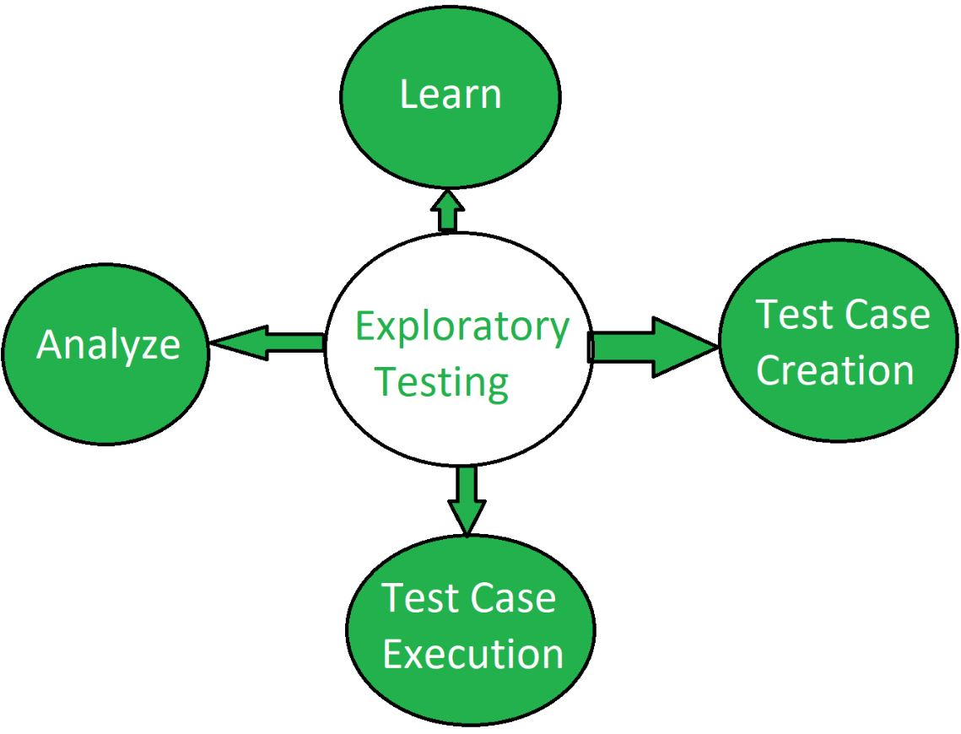

12. **What is traceability matr**ix?

* RTM stands for **Requirement Traceability matrix**.
* RTM maps all the requirements with the test cases.
* By using this document one can verify test cases cover all functionality of the application as per the requirements of the customer.
* **Requirements:** Requirements of a particular project from the client

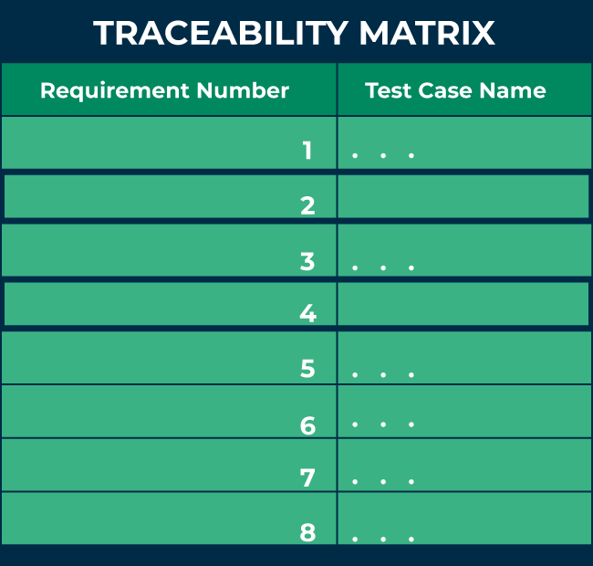**Traceability:** The ability to trace the tests.

**Matrix:** The data which can be stored in rows and columns form.

The main purpose of the requirement traceability matrix is to verify that the all requirements of clients are covered in the test cases designed by the testers.  
In simple words, one can say it is a pen and pencil approach i.e., to analyze the two data information but here we are using an Excel sheet to verify the data in a requirement traceability matrix.

## Why is ****Requirement Traceability Matrix****(RTM) Important?

* When business analysis people get the requirements from clients, they prepare a document called [SRS (System/Software Requirement Specification)](https://www.geeksforgeeks.org/software-requirement-specification-srs-format/) and these requirements are stored in this document.
* If we are working in the [Agile model](https://www.geeksforgeeks.org/software-engineering-agile-development-models/), we call this document Sprint Backlog, and requirements are present in it in the form of user stories.
* When QA gets the SRS/Sprint backlog document they first try to understand the requirements thoroughly and then start writing test cases and reviewing them with the entire project team.
* But sometimes it may happen that in these test cases, some functionality of requirements is missing, so to avoid it we required a requirement traceability matrix.
* Each [test case](https://www.geeksforgeeks.org/software-testing-test-case/) is traced back to each requirement in the RTM. Therefore, there is less chance of missing any requirement in testing, and 100% test coverage can be achieved.
* RTM helps users discover any change that was made to the requirements as well as the origin of the requirement.
* Using RTM, requirements can be traced to determine a particular group or person that wanted that requirement, and it can be used to prioritize the requirement.
* It helps to keep a check between requirements and other development artifacts like technical and other requirements.
* The Traceability matrix can help the tester identify whether by adding any requirement previous requirements are affected or not.
* RTM helps in evaluating the effect on the QA team to reuse the test case.

## Parameters of ****Requirement Traceability Matrix****(RTM):

* The below figure shows the basic template of RTM. Here the requirement IDs are row-wise and test case IDs are column-wise which means it is a forward traceability matrix.
* From the figure below, it can be seen that: RTM

**The following are the parameters to be included in RTM:**

1. **Requirement ID:** The requirement ID is assigned to every requirement of the project.
2. **Requirement description:** for every requirement a detailed description is given in the SRS (System/Software Requirement Specification) document.
3. **Requirement Type:** understand the type of requirements i.e., banking, telecom, healthcare, traveling, e-commerce, education, etc.
4. **Test cases ID:** the testing team designs test cases. Test cases are also assigned with some ID.

## Types of Traceability Matrix:

**There are 3 types of traceability matrix:**

1. **Forward traceability matrix**
2. **Backward traceability matrix**
3. **Bi-directional traceability matrix**

### ****1. Forward traceability matrix:****

* In the forward traceability matrix, we mapped the requirements with the test cases.
* Here we can verify that all requirements are covered in test cases and no functionality is missing in test cases.
* It helps you to ensure that all the requirements available in the SRS/ Sprint backlog can be traced back to test cases designed by the testers.
* It is used to check whether the project progresses in the right direction.

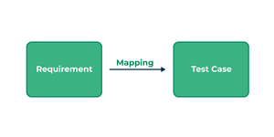

Forward traceability matrix

**In forwarding the traceability matrix:**

*Rows = Requirement ID*

*Column = Test case ID*

### ****2. Backward traceability matrix:****

* In the backward traceability matrix, we mapped the test cases with the requirements.
* Here we can verify that no extra test case is added which is not required as per our requirements.
* It helps you to ensure that any test cases that you have designed can be traced back to the requirements or user stories, and you are not extending the scope of the work by just creating additional test cases that cannot be mapped to the requirement.
* The backward traceability matrix is also known as the **reverse traceability matrix**.

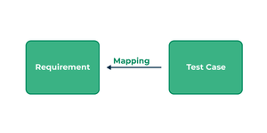

Backward traceability matrix

**In the**Excel **backward traceability matrix:**

*Rows = Test cases ID*

*Column = Requirement ID*

### ****3. Bi-directional traceability matrix:****

* A bi-directional traceability matrix is a combination of a forward traceability matrix and a backward traceability matrix.
* Here we verify the requirements and test cases in both ways.

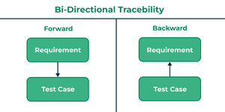

Bi-directional traceability matrix

Bi-directional traceability matrix = Forward traceability matrix + Backward traceability matrix

**Who Needs Requirement Traceability Matrix (RTM)?**

When testers design the test cases they need to check whether test cases cover all functionality of the application as per the requirements of the customer given in the SRS/Sprint backlog.

* To verify that they need a requirement traceability matrix.
* They generally use an Excel sheet or Google spreadsheet for RTM.

## How To Create RTM?

Before creating RTM SRS/Sprint backlog documents and test cases documents are required. Below are the steps to create RTM:

1. For RTM we will use an Excel sheet.
2. Write the name of the project, date, and name of the person who is responsible for RTM.
3. Write all requirement IDs row-wise in the first column of an Excel sheet.
4. Write all the requirement descriptions row-wise in the second column of an Excel sheet.
5. Write all the requirements type row-wise in the third column of an Excel sheet.
6. Write all the test cases with their IDs column-wise in an Excel sheet.
7. After writing all requirements and test cases you have to verify that for every requirement you have prepared the test cases in both positive and negative flow.

## Advantages of RTM:

Below are some benefits of using RTM:

1. **Full test coverage:**RTM confirms the 100% test coverage.
2. **Verify missing functionality:**This document is helpful for the tester to check there is not any functionality missed while testing the application.
3. **Helps to prioritize and track requirements:**It also helps to understand what extra test cases we added that are not part of the requirement.
4. **Helps to track test status:**It is easy to keep track of the overall test status.
5. **Proper consistent documentation:**RTM can help in the effort to provide proper and consistent documentation for the team.
6. **Versioning is easier:**RTM helps to keep track of the required modifications and how they impact every part of the project.

## ****Requirement Traceability Matrix****(RTM) Template:

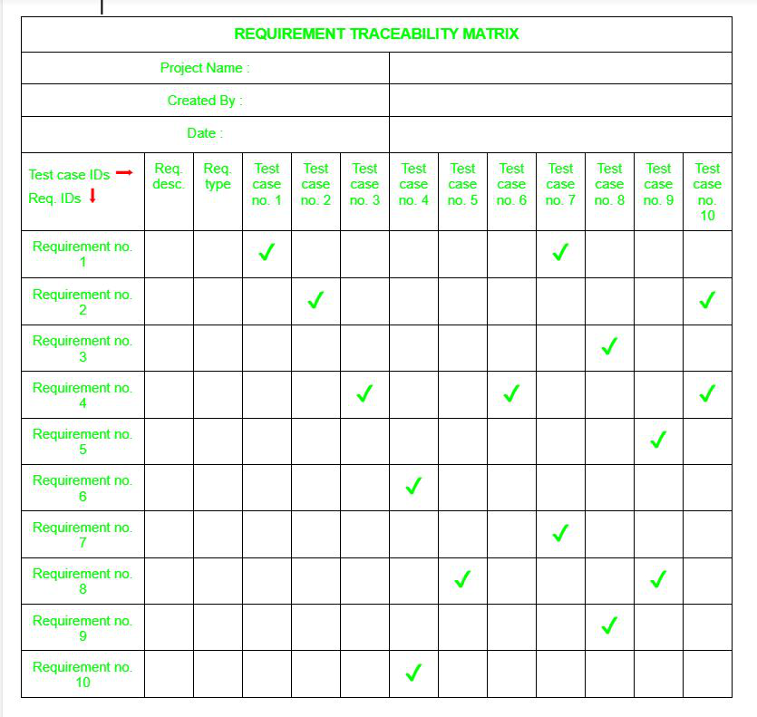The below figure shows the basic template of RTM. Here the requirement IDs are row-wise and test case IDs are column-wise which means it is a forward traceability matrix.

From the figure below, it can be seen that:

* For verifying requirement number 1 there are test cases number 1 and 7.
* In requirement number 2 there are test cases number 2 and 10 and similarly, for all other requirements, there are test cases to verify them.